Name: - khan naseer Sem: - III
Roll no: - 25BIT34 Sub: - Computer Network
Class: - SY-BSCIT Batch:-2

Setup an FTP server on Linux and transfer files between client and server.

🖥️ FTP
(File Transfer Protocol)
Configuring FTP Server In Packet Tracer

FTP (File Transfer Protocol) is a standard network protocol used specifically to transfer computer files from one host to another over the internet. While HTTP is optimized for loading web pages, FTP is built entirely for moving bulk files.

STEP 1:- OPEN PACKET TRACER
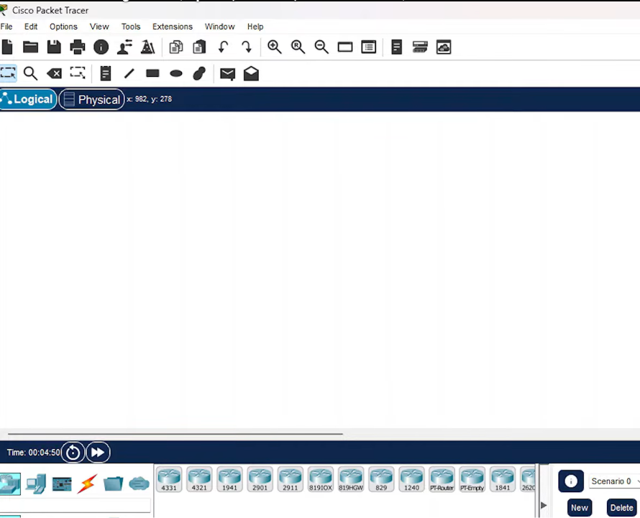
STEP 2:- WE NEED ROUTER SWITCH PC’S & SERVER YOU CAN SELECT IT FROM BOTTOM LEFT CORNER IN PACKET TRACER
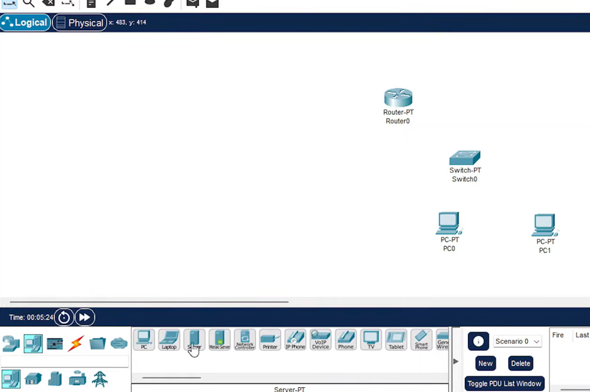

STEP 3:- CONNECT THEM USING CONNECTION CABLE AND CONNECT PC’S TO SWITCH, SWITCH TO ROUTER, ROUTER TO SERVER
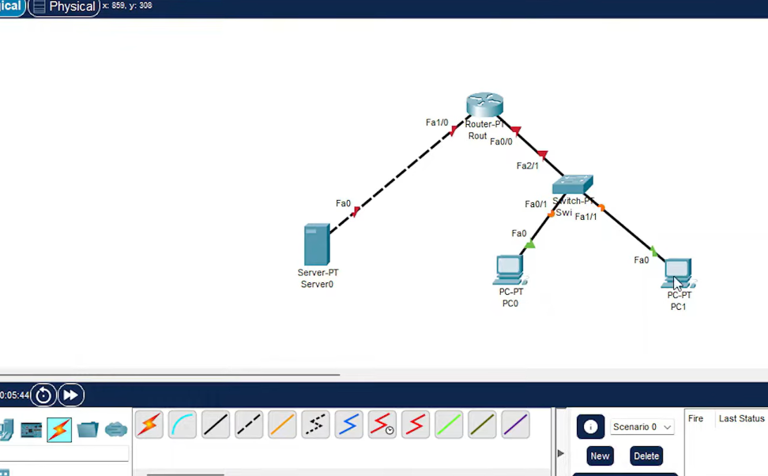

STEP 4:- CONFIGURE PC > PC0 > DESKTOP > IP CONFIGURATION > IPV4-192.168.1.2 > SUBNET MASK > DEFAULT GATEWAY-192.168.1.1
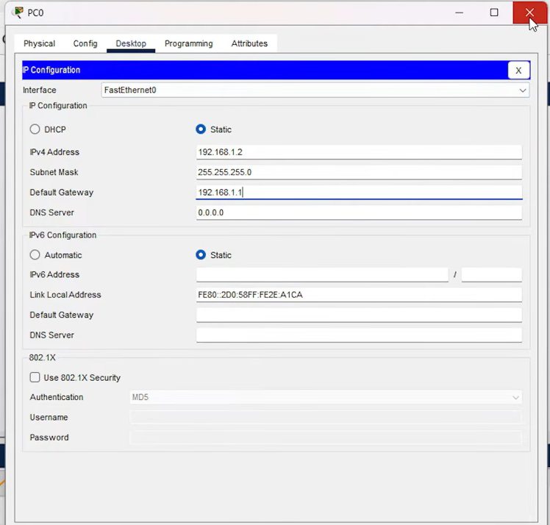

STEP 5:- PC1> DESKTOP > IP CONFIGURATION > IPV4-192.168.1.3 > SUBNET MASK > DEFAULT GATEWAY-192.168.1.1
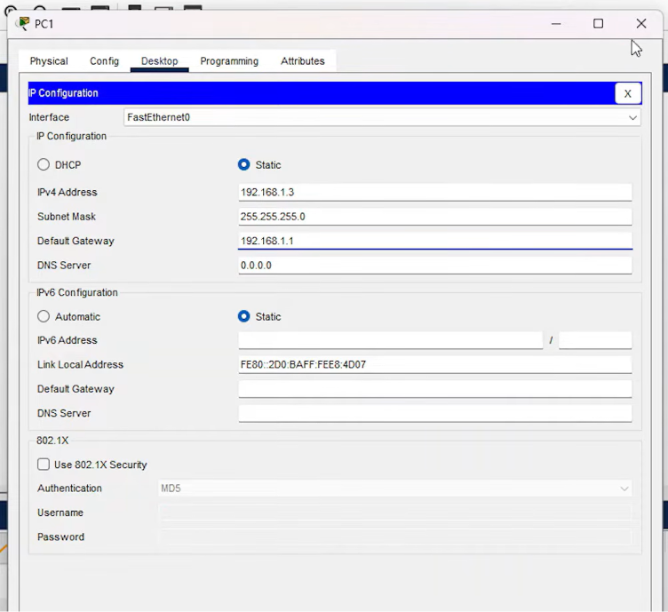

STEP 6:- RENAME SERVER 0 AS FTP SERVER > DESKTOP > IP CONFIGURATION > IPV4-10.10.10.1 > SUBNET MASK > DEFAULT GATEWAY- 10.10.10.0
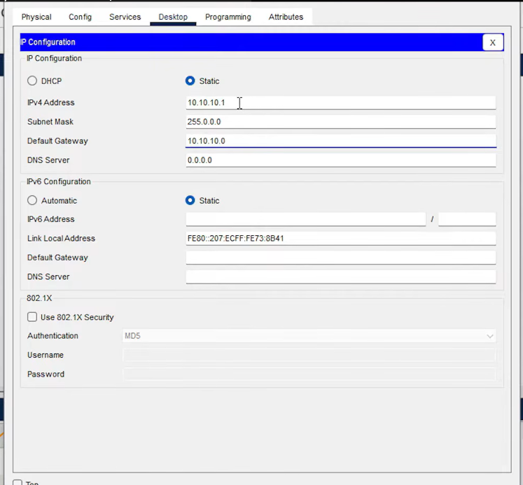

STEP 7:-
(1)ROUTER > CONFIG > INTERFACE > (LOOK AT THE CONNECTION EX:- FASTETHERNET) FASTETHERNET0/0 > PORT STATUS-ON > IP CONFIGURATION IPV4-ADDRESS-192.168.1.1 > SUB NET MASK(WE HAVE GIVEN THIS IP BECAUSE ROUTER IS CONNECTED TO PC’S THROUGH SWITCHES)
(2) ROUTER > CONFIG > INTERFACE > (LOOK AT THE CONNECTION EX:- FASTETHERNET) FASTETHERNET0/1 > PORT STATUS-ON > IP CONFIGURATION IPV4-ADDRESS-10.10.10.0 > SUB NET MASK(WE HAVE GIVEN THIS IP BECAUSE ROUTER ON THE OTHER CABLE IS CONNECTED TO SERVER)
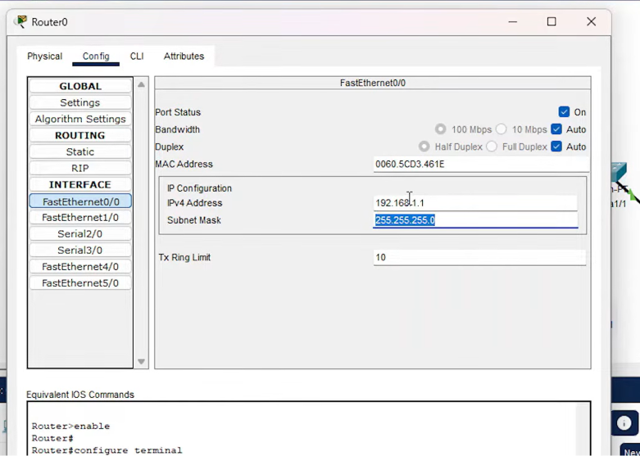
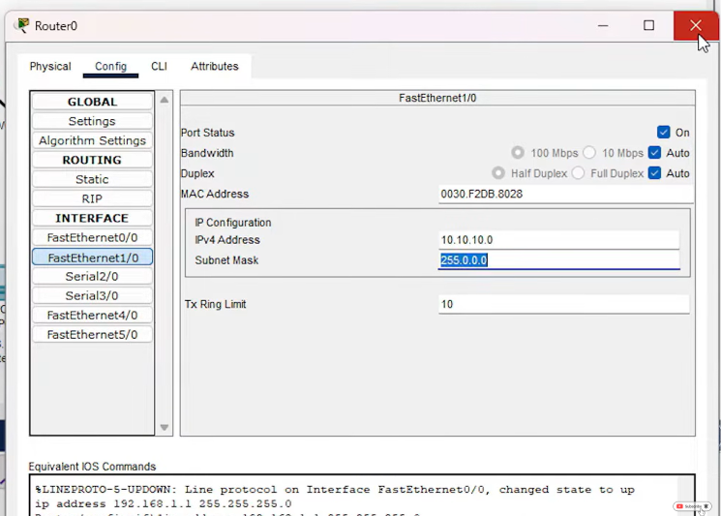

STEP 8:- SERVER > SERVICE > FTP > SERVICE-ON > GIVE USERNAME-ftpuser PASSWORD-test > CHECK ALL FIVE BOXES > ADD
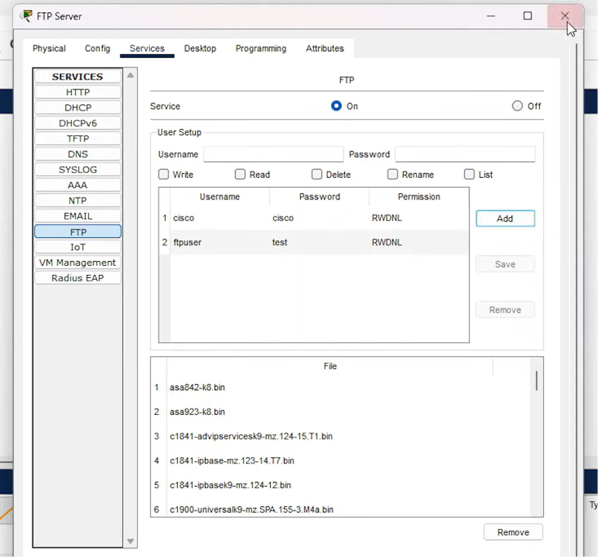

STEP 9:- VERIFY FTP IN PC PCO > TEXT EDITOR > WRITE A MESSAGE > EX:-HELLO USER > CTRL+S (TO SAVE THE FILE) > NAME FILE-FTP.TXT > OK > OPEN COMMAND PROMPT > WRITE : dir THEN PRESS ENTER(TO KNOW WHAT FILES IT CONTAINS ) > :ftp 10.10.10.1 THEN PRESS ENTER(IT WILL ASK USER NAME AND PASSWORD) > ENTER USERNAME-ftp PASSWORD-123 THEN PRESS ENTER
TYPE> dir > WHAT FILE IT CONTAINS IN DIRECTORY AND THEN TO ADD THE FILE IN FTP SERVER :put ftp.txt PRESS ENTER(FILE WILL BE TRANSFER) YOU CAN DO THE SAME IN OTHER PC’S
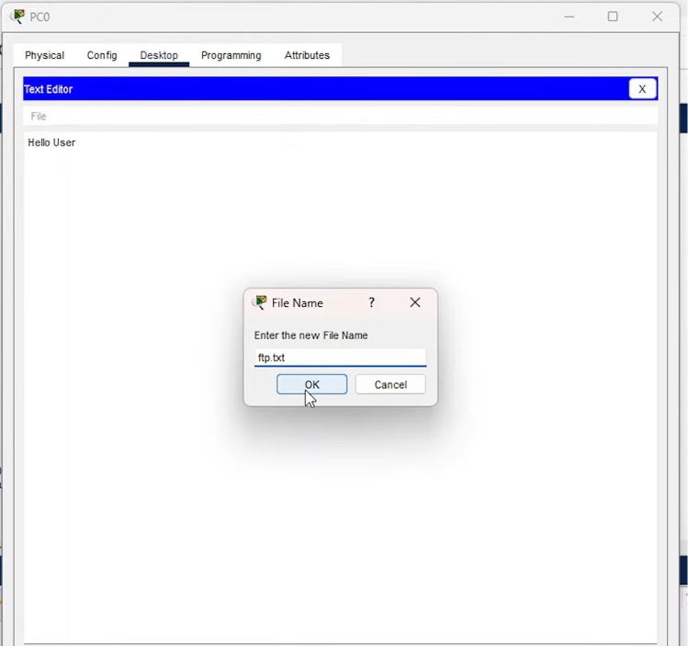

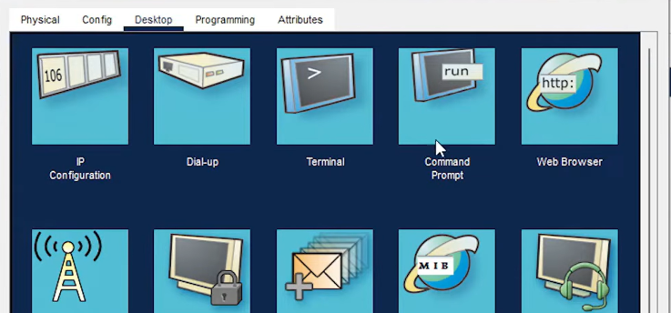

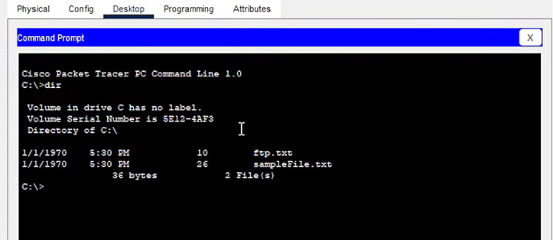

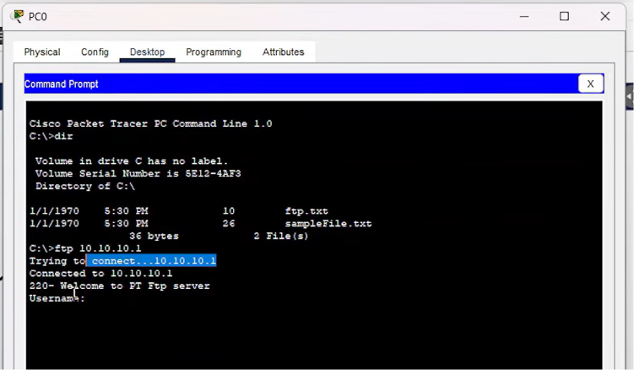
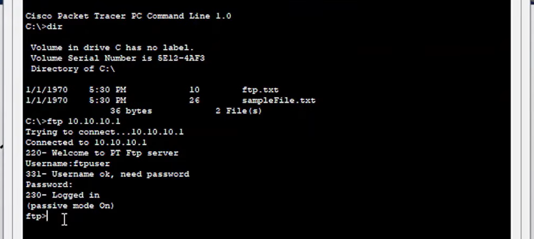

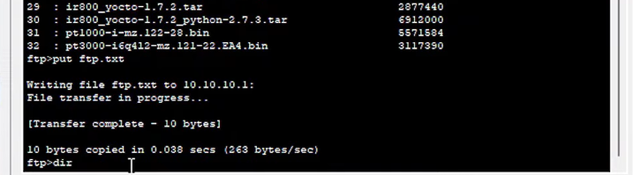
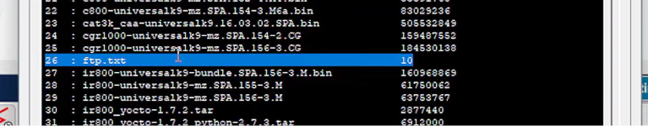

STEP 10:- HOW TO RETRIEVE THE FILE IN THE PC > :get ftp.txt > THAN IT WILL BE DOWNLOADED AND SAVED IN PC’S > TO CHECK THE FILE IS DOWNLOADED OR NOT :dir (IT WILL SHOW THE DOWNLOADED PC)
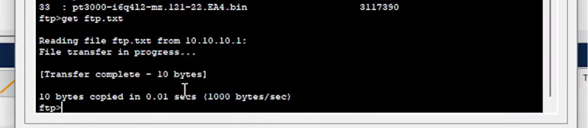

STEP 11:- TO DELETE THE FILE :delete ftp.txt THE FILE WILL BE DELETED TO CHECK THAT :dir (THERE WILL BE NO FTP FILE IN DIRECTORY)
